**HKID Card Identification SDK-IOS Documentation**

**Jun 2019**

Version 1.0



© 2019 TransUnion LLC  
All Rights Reserved

No part of this publication may be reproduced or distributed in any form or by any means, electronic or otherwise, now known or hereafter developed, including, but not limited to, the Internet, without the explicit prior written consent from TransUnion LLC.

Requests for permission to reproduce or distribute any part of, or all of, this publication should be mailed to:

Law Department  
TransUnion  
555 West Adams   
Chicago, Illinois 60661

The “T” logo, TransUnion, and other trademarks, service marks, and logos (the “Trademarks”) used in this publication are registered or unregistered Trademarks of TransUnion LLC or their respective owners. Trademarks may not be used for any purpose whatsoever without the express written permission of the Trademark owner.

[transunion.com](http://www.transunion.com/)

**Document History**

|  |  |  |  |
| --- | --- | --- | --- |
| **Version** | **Description** | **Prepared By** | **Date** |
| 1.0 | Initial version | TU | Jun 5, 2019 |
|  |  |  |  |
|  |  |  |  |
|  |  |  |  |
|  |  |  |  |
|  |  |  |  |
|  |  |  |  |
|  |  |  |  |
|  |  |  |  |
|  |  |  |  |

Table of Contents

1. Introduction 5

1.1. Objective 5

1.2. Version Support 5

2. SDK Integration 5

2.1. Extract SDK 5

2.2. Importing the SDK 5

2.3. Adding necessarily frameworks 5

3. SDK Description 6

3.1. Header file description 6

3.1.1. DSLHKIDCardSDK.h 6

3.1.2. DSLHKIDCardDetectObserverDelegate.h 7

4. SDK Usage 7

4.1. Example of using the SDK 7

# Introduction

## Objective

Describe the details and usage of HKID Card Identification SDK for third parties.

## Version Support

iOS 8.0 or above.

# SDK Integration

## Extract SDK

* Unzip DSLHKIDCardSDK.zip：



## Importing the SDK

* Import the unzipped DSLHKIDCard.framework by dragging it into your Xcode project:

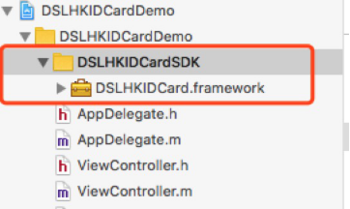

## Adding necessarily frameworks

* In General, add DSLHKIDCard.framework into Embedded Binaries:

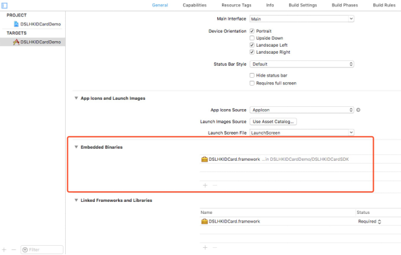

# SDK Description

## Header file description

### DSLHKIDCardSDK.h

* Interface description:

/**

Start HKID card detection

*/

+(**void**)startDetect;

/**

Reset the SDK after quit scanning

*/

+(**void**)resetStatus;

/**

Set callback object

**@param** observer The callback object

*/

+(**void**)registerObserver:(**id**<DSLHKIDCardDetectObserverDelegate>)observer;

/**

Unset the callback object

**@param** observer The callback object

*/

+(**void**)unregisterObserver:(**id**<DSLHKIDCardDetectObserverDelegate>)observer;

/**

Add image data for identification

**@param** imageData The image data

*/

+(**void**)addDetectBufferData:(NSData *)imageData;

/**

Set ID card type

**@param** isNewIDCard YES: New ID card; NO: Old ID card

*/

+(**void**)setIDCardType:(**BOOL**)isNewIDCard;

/**

Get current SDK version number

**@return** Current version number

*/

+(NSString *)getVersion;

### DSLHKIDCardDetectObserverDelegate.h

* Interface description:

/**

Called when an operation command is completed

**@param** command Refer to DSLHKIDCardNextOperation class for details

*/

-(**void**)didUpdateOperationCommand:(DSLHKIDCardNextOperation *)command;

/**

Called when identification has result

**@param** result Refer to DSLHKIDCardResult class for details

*/

-(**void**)didDetectResult:(DSLHKIDCardResult *)result;

# SDK Usage

## Example of using the SDK

Refer to the code of the Sample project provided